**BESANT EVENING COLLEGE**

**MAHATMA GANDHI ROAD**

**KODIALBAIL MANGALURU 575003**

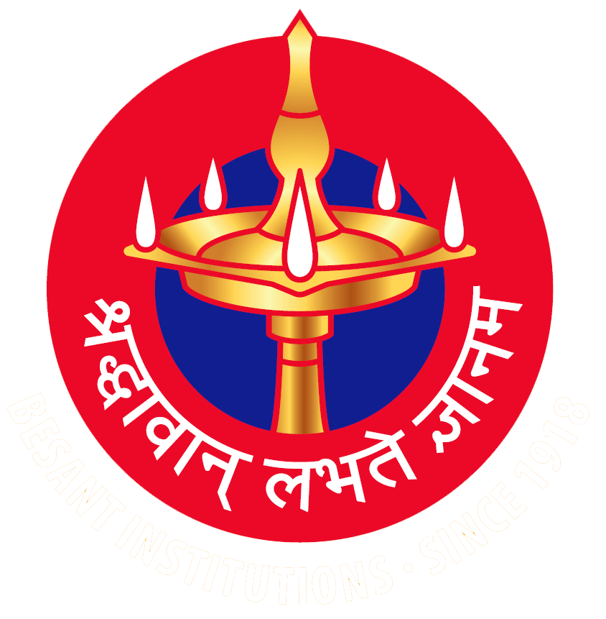

**Statutory Declaration under**

**Section 4(1)(b) of the RTI Act 2005**

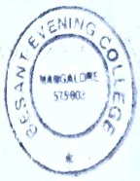

|  |  |
| --- | --- |
| Name of the Institution | Besant Evening College |
| Address | Besant Evening College, M.G Road, Kodialbail Mangaluru 575003 Karnataka State |
| Website | https://bec.besant.edu.in/en/ |
| E-mail | Besant_eveningcollege@yahoo.co.in |
| Phone No | 0824-2491204 |
| Affiliated to | Mangalore University |
| Managed by | Women’s National Education Society (WNES) |
| Principal | Dr. Lakshminarayana Bhat A |
| RTI Officer | Smt. Vidya Hegde Phone:0824 2491204 |
| Applet Authority  Principal | Phone Office:0824-2491204  Cell:9481976995 |
| Brief Profile of the  College | Besant Evening College founded on a noble idea and the first co-education institution sponsored by Women’s National Education Society in the year 1796 by late Manel Srinvas Nayak to provide educational opportunities to employed youth. With the motto of ‘Learn while they Earn’. Besant Evening College admits students who have limited economic resources.  The college was declared open in the month of October 1976. Indeed Besant Evening College owes much to the missionary zeal of visionaries like Late Manel Srinivas Nayak, the founder President. Late b Damodar Prabhu and Late Manel Krishna Nayak, the former presidents and many more who endeavoured to build this edifice of learning.  Besant Evening College is a grant-in aid College recognised by the UGC under 2(f) and 12B. The college is centrally located in the city of Mangaluru.  The College holds classes late in the evening especially designed to offer higher education to working students of a disadvantage background.  The College has a dynamic Management, blend of experienced and young and young faculty, vibrant Alumni Association and a supportive PTA. The College offeres three year B.Com programme and a Post Graduate M.Com Programme. |

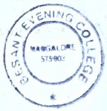

**BOARD OF TRUSTEES**

**WOMEN’S NATIONAL EDUCATION SOCIETY, KODIALBAIL,**

**MANGALURU-575003**

**(Registered under Act XXI of 1860 No. 8 1942-43 dated 22-3-1943)**

List of names of members of the Governing Body of the Women’s National Education Society, Mangaluru-575003, to which as per the rules of the society, the management of its affairs is entrusted for the year 2024-25

|  |  |  |
| --- | --- | --- |
| Sl.No | Name | Designation |
| 1 | Sri. Manel Annappa Nayak | President |
| 2. | Dr. Manjula K.T | Vice-President |
| 3. | Sri Suresh Pai | Vice-President |
| 4. | Sri. Jeevandas Narayan | Secretary |
| 5. | Sri. M.P Bhat | Treasurer |
| 6. | Sri. Nagar Narayan Shenoy | Member |
| 7. | Sri. Sathish Kumar Bhat | Member |
| 8. | Sri. Shyamsundar Kamath V | Member |
| 9. | Dr. Arjun Srinivas Nayak Manel | Member |
| 10 | Sri. B Ganesh Krishna Bhat | Member |
| 11 | Sri. M. Narasimhadas Pai | Member |

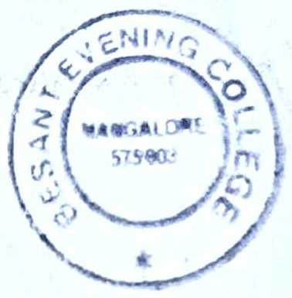

**MANAGING COUNCIL OF THE COLLEGE 2023-24**

|  |  |  |
| --- | --- | --- |
| Sl.No | Name | Designation |
| 1. | Sri. Manel Annappa Nayak | President |
| 2. | Sri. B Ganesh Krishna Bhat | Correspondent |
| 3. | Dr. Manjula K.T | Member |
| 4. | Sri. Jeevandas Narayan | Member |
| 5. | Dr. Arjun Srinivas Nayak Manel | Member |
| 6. | Sri. Sathish Kumar Bhat | Member |
| 7. | Sri Suresh Pai | Member |
| 8. | Dr. Lakshminarayana Bhat A | Principal |
| 9. | Sri Gopala Raddi V Ritti | Staff Representative |
| 10. | Dr. Prasanna Kumar M.G | Staff Representative |
| 11. | Sri. Ganesh Bhaktha | PTA President |



Full-time Faculty Members of the College 2024-25

|  |  |  |  |
| --- | --- | --- | --- |
| Sl. No | Name | Designation | Qualification |
| 1. | Dr. Lakshminarayana Bhat A | Principal | M.A, PhD |
| 2. | Mr. Gopalraddi Ritti | Asso Professor | M.Com |
| 3. | Dr. Prasanna Kumar M G | Asst. Professor | M.Com Ph. D |
| 4. | Mrs. Srividya | Asst. Professor | M.Com |
| 5. | Mrs. Amitha | Asst. Professor | M.Com |
| 6. | Mr. Mohammad Musthaf | Asst. Professor | M.Com, M.A |
| 7. | Mrs. Sushma | Asst. Professor | M.A |
| 8. | Mr Harish Pai | Asst. Professor | M.Com |
| 9. | Dr. Vasappa Gowda | Sl. Grade Librarian | M.Com, M. Li Sc., PGDCA, PhD |

 